PINK ROT PRODUCTIONS

Visual
  - – drawing of your site, showing the structure and pages
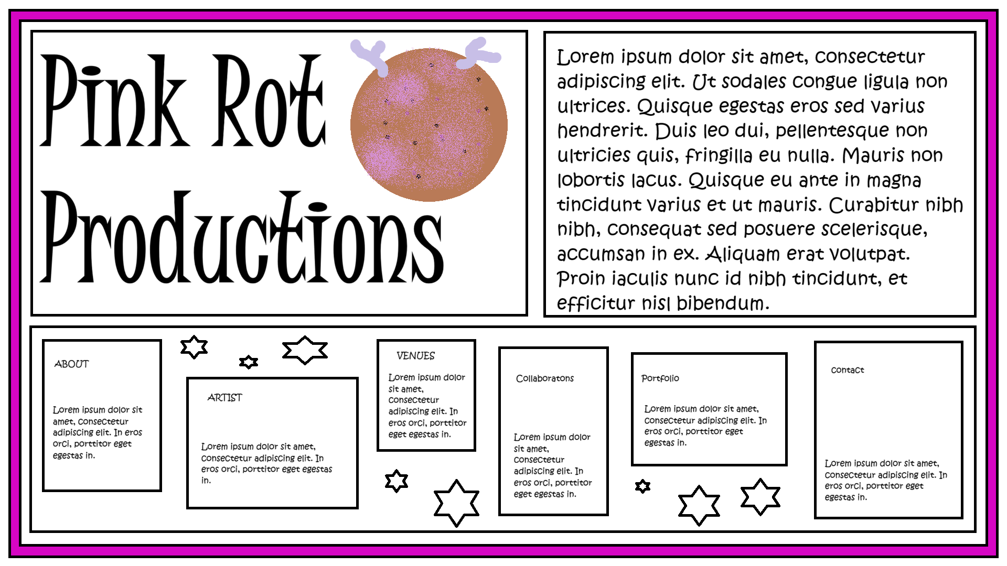
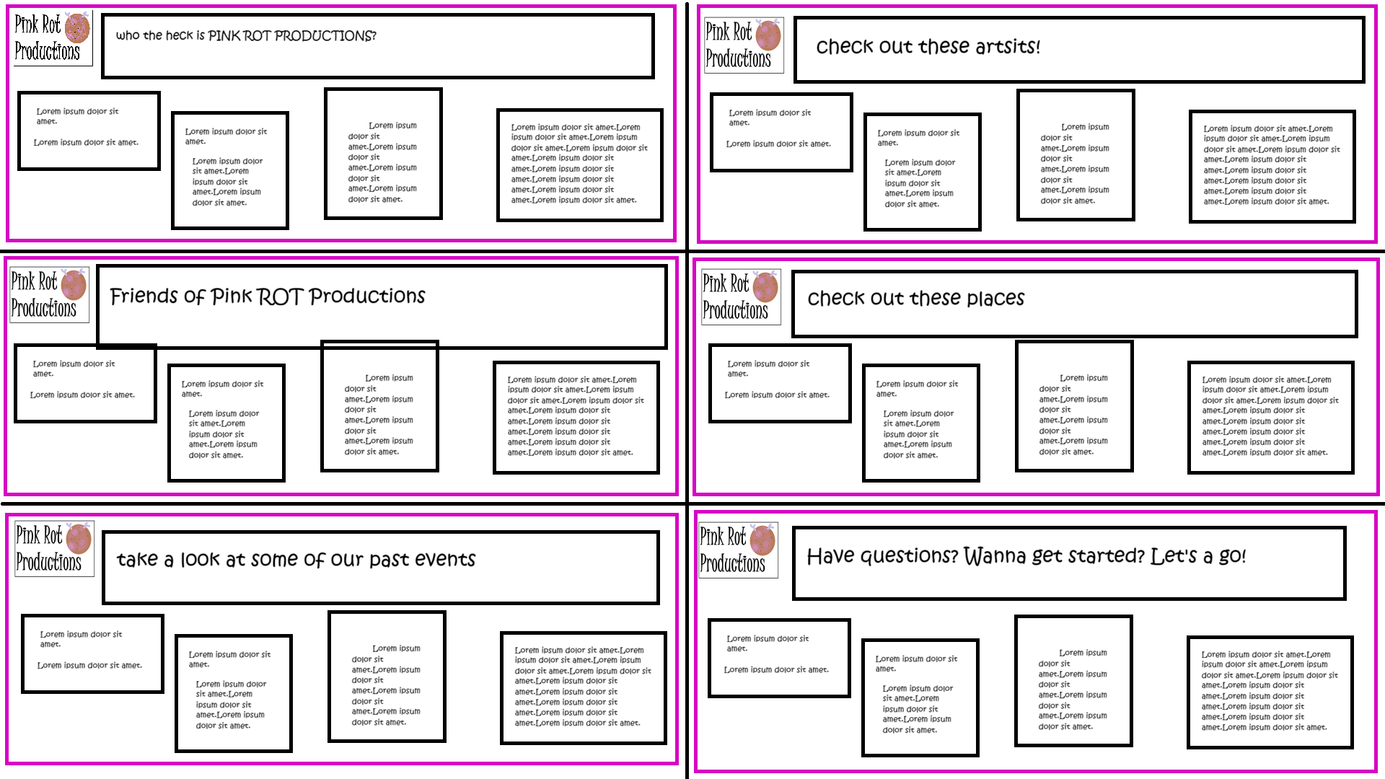

Statement of Purpose
  - – why are you creating this site?
At Pink Rot Productions, we feel there is a need for more collaboration amongst the arts and the community in Ottawa. We want to create an affordable event curation service featuring local, independent, touring artists. With this website, we will be able to connect with potential clients, and make it easier for them to access our services. We want our artists to connect and succeed in their pursuit of passion for the arts.

Audience
  - – who is the target audience for this web site?
Our audience includes local artist, independent artists, touring artists, venues, and members of the community who want to host an event featuring some sort of art.

Research
  - – Pink Rot Productions vs Similar Sites.
The websites listed below have similar purpose for wanting to serve the community, but they either charge clients to be on the website, are limited to one venue, or the benefit of one place, or one art. Pink Rot Productions seeks to connect the ever-growing independent artists in Ottawa or touring artists and the community so that they can increase their independence. Pink Rot Productions is more of a tool than a business for profit, although there may be some expenses depending on needs.
https://www.ottawashowbox.com/music-companies/
https://rawartists.com/what-is-raw
https://artscourt.ca/organization-directory

Content
  - – what kind of content will you be putting on the web site?
Portfolio of events
- media capturing past events that may include audio, video, photographs, literature, reviews
Inspiration for future events
- potential clients can find inspiration on our website for events that are not in our portfolio, but we can coordinate
Featured artists
- a little bio
- links to their content
Featured venues
- a description including location, vibe, crowd, prices, size, possibilities
- links to their content
Featured events
- a showcase of events we curate
- a calendar of local, independent art events happening in Ottawa and the surrounding area
- networking opportunities
What to expect
- a guide on how to book with us including information we need from the client, and the process of curating an event with us
- our policies, procedures, purpose, terms and conditions

Layout
  - – what kind of layout do you want?
Home page to navigate
- brief explanation of each page to help the user navigate
  - click here if you’re curious about…
  - are you looking for ….
About
- talks about our policies, procedures, purpose, terms and conditions
Artists
- this page includes artists with whom we’ve connected
- organized by art sect, location, genre?
Venues
- this page includes venues with which we work, but are not limited to them
- lists event spaces in Ottawa and the surrounding area
Collaboration
- local and distant partners and affiliates of Pink Rot Productions
  - venues
  - artists
  - promoters
  - socialites
  - communities
Portfolio of Events
- media from or about past events
Contact
- a guide on how to book with us including information we need from the client, and the process of curating an event with us

